**Star photographer René Staud to present an exclusive 'Milestones’ work to Joachim Eberhardt, President & CEO, Jaguar Land Rover North America, LLC**

**Contact:**

**Hahnemühle FineArt GmbH**

Ann Kristin Plüss

Hahnestraße 5   
D – 37586 Dassel  
Germany  
annkristin.pluess@hahnemuehle.com

**Hahnemuehle US**

**Carol Boss**

**carol@hahnemuhleusa.com**

**380 N. Terra Cotta Rd, Suite G**

**Crystal Lake, IL 60012**



René Staud and Hahnemühle FineArt are pleased to announce the ‘Milestones’ book project. The coffee-table book will be published in a limited edition of 125 copies and captures the essence of René Staud's fascinating automobile photography. Each page will be printed as a FineArt print on Hahnemühle Photo Rag® 308.

The US première will take place at 3:30 pm on 21 October 2016, when René Staud will present one of the first copies to Joachim Eberhardt, President & CEO, Jaguar Land Rover North America in an exclusive ceremony.

### Plan your Photo Plus Expo visit with us. We look forward to welcoming you at our booth #437.

**About Hahnemühle**

Established in 1584, Hahnemühle invented the digital artist papers fifteen years ago and is considered the pioneer of exclusive and above all durable papers for photography and art reproductions. The papers – for more than 430 years made ​​in the paper manufactory – are provided now with an ink receiving layer that does not affect the feel of the paper. The paper offers in conjunction with the so-called inkjet coating for photo prints rich colors, a wide color gamut and sharp details.

International artists exhibit their work on the more than 20 different papers from Hahnemühle´ s portfolio. In the world of photography and collector’s prints on Hahnemühle paper have a great reputation. The papers “Made in Germany” are sought-after in 80 countries around the world. Worldwide, Hahnemühle has 180 employees in Dassel, Germany (headquarters); Norwich, United Kingdom; Paris, France; Chrystal Lake, Illinois, USA and Beijing, China. www.hahnemuehle.com

**About René Staud**

Born in 1951, René Staud's interest in photography inspired him to take numerous photography courses during his school years. After an apprenticeship in a portrait and photography shop, Staud struck out on his own. Initially focused on wedding photography and photojournalism, Staud soon understood the great demand for high-quality advertising and product photography. He opened his first studio in Wendlingen in 1975.

Staud's big breakthrough came with the development of Magicflash®, a flash technology specially designed for the needs of studio photography. The automotive industry in particular was enthusiastic about the system’s potential and, thanks also to growing demand from customers and manufacturers, Staud was able to open a major studio space in Leonberg in 1986.

**About Joachim Eberhardt**

Joachim (Joe) Eberhardt became President & CEO of Jaguar Land Rover North America, LLC. on December 18, 2013. Eberhardt reports directly to Andy Goss, Group Sales Operations Director, Jaguar Land Rover and is responsible for Jaguar Land Rover's North American operations including Sales, Service and Marketing in the United States and Canada.   
  
Eberhardt comes to Jaguar Land Rover North America with over 25 years of global industry and retail experience, including executive leadership sales, marketing and service roles at Chrysler Group, DaimlerChrysler UK, Mercedes-Benz U.S.A. and Daimler-Benz AG. He brings to Jaguar Land Rover a proven record for boosting both sales and brand reputation and expansion in U.S. and global markets under his direction.   
  
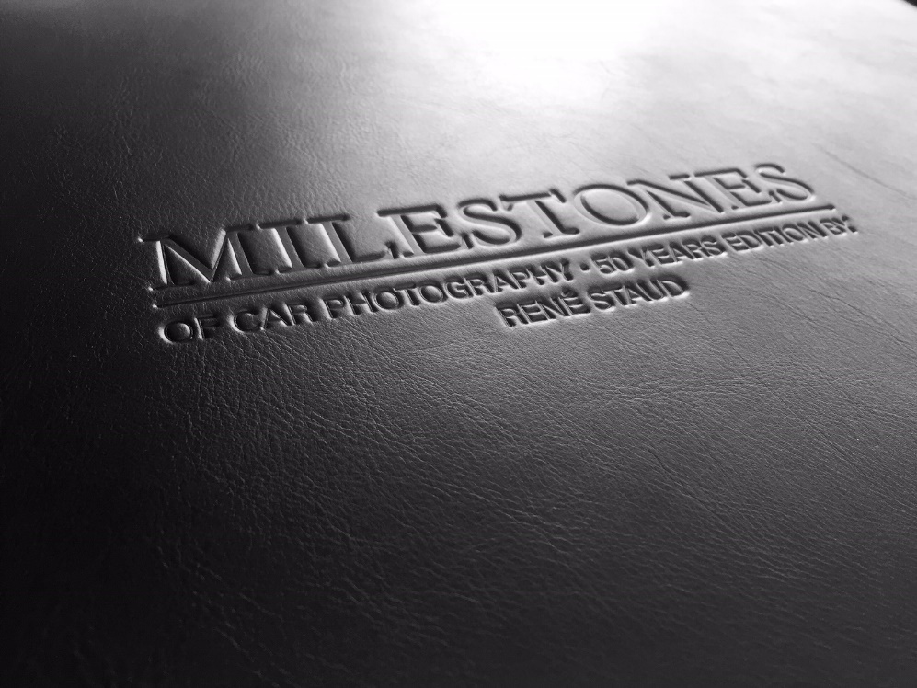

**About ‘Milestones’**

The 286-page work was presented in September at the leading global trade fair for photography, the Photokina in Cologne. 125 signed prints of one of the Milestones images were available for sale to interested fair visitors. This exclusive edition was available on 22 September at the Hahnemühle stand, Hall 3.1, A25.

With over 35 years of experience in the field of advertising photography, the name René Staud is inextricably linked with some of the most illustrious brands in the automotive industry. His elaborate image worlds have undoubtedly played a role in shaping the public perception of Aston Martin, Mercedes-Benz and Porsche. Staud also deftly portrays the top models of other premium brands such as Maserati, Audi, BMW, Bugatti and Mini in perfectly staged encounters with contemporary art or architecture. The highlights of the book are unquestionably the photographic creations to mark the re-birth of the Maybach brand and landscape compositions for Aston Martin in Greenland and Island.